Name : Ansari M.Saeem M.Saleem
Uid : 2019430001
Subject : NAD
Expt no : 1
Aim : Write a program to request a file from client to server and send file data from server to client using TCP/IP protocol.

Aim:
Write a program to transfer the content of a requested file from server to client using TCP/IP sockets.

Objectives:
- Implementation of socket programming for client server communication using C programming language.
- Implementation of File handling concepts in C programming language.

Theory:
The Internet protocol suite is the conceptual model and set of communications protocols used in the Internet and similar computer networks. It is commonly known as TCP/IP because the foundational protocols in the suite are the Transmission Control Protocol (TCP) and the Internet Protocol (IP). During its development, versions of it were known as the Department of Defense (DoD) model because the development of the networking method was funded by the United States Department of Defense through DARPA.

Methodology:

Results:
Server
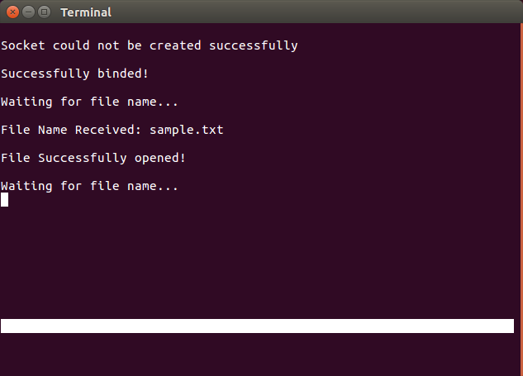

Client :
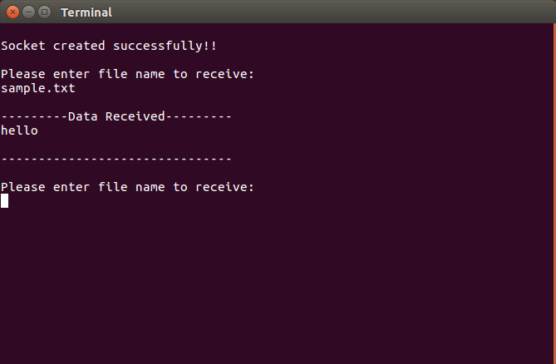

Conclusion:
Here we can conclude that ford-fulkerson’s algorithm is used to calculate maximum flow in a network. Time complexity of this algorithm is directly propotional to the no of nodes in network and max capacity.

